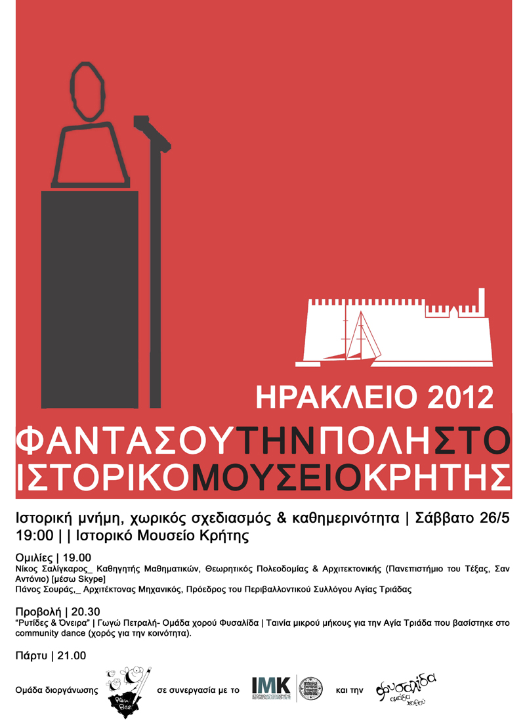

Πρόγραμμα:
http://cargocollective.com/imaginethecity/Fantasoy-tin-poli-Irakleio-2012

